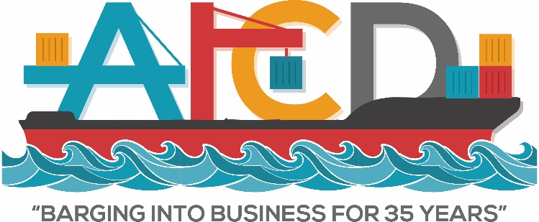
SATURDAY - MAY 16, 2020
Start Time | End Time | Function | Location
12:00 PM | 11:00PM | Exhibit Setup | Savannah Convention Ctr.

SUNDAY - MAY 17, 2020
8:00AM | 2:00PM | Exhibit Setup | Savannah Convention Ctr.
8:30AM | 9:00AM | Continental Breakfast – Board Meeting
9:00AM | 12:00PM | AICD Board Meeting
2:00PM | 4:00PM | Member Registration
3:00PM | 7:00PM | Welcome Reception & Exhibits | Savannah Convention Ctr.
MONDAY - MAY 18, 2020
7:00AM | 8:00AM | Continental Breakfast
8:00AM | 8:30AM | AICD General Business Meeting (Members only)
8:30AM | 10:00AM | J.R. Gillette – The Economy and Your Business
10:00 AM | 3:00 PM | Spouse Event – Walking Food Tour | ---------
10:00AM | 10:15AM | AM Break
10:15AM | 11:45AM | Jay Johnson – Employee Management and Sales
11:45AM | 12:45PM | Lunch
12:45PM | 2:15PM | Pete Susca – It’s Bigger Than Safety
2:15PM | 3:15PM | Platinum Sponsor Reception (Platinum Sponsors & Members Only)
3:15PM | 4:00PM | Free Time (Vendors Only in Trade Show) | Savannah Convention Ctr.
4:00PM | 7:00PM | Trade Show/Exhibition | Savannah Convention Ctr.
6:00PM | 7:00PM | Dinner Served Within Trade Show | Savannah Convention Ctr.
TUESDAY - MAY 19, 2020
7:00AM | 8:30AM | Continental Breakfast
8:00 AM | 8:30AM | Exhibitor Wrap Up (Vendors Only)
8:00AM | 12:00PM | Exhibitor Tear Down
8:30AM | 10:30AM | Celebrity Speaker - Joe Theismann
10:30AM | 11:00AM | Wrap Session (Members Only)
9:45 AM | 12:00 PM | Spouse Event – Narrated Riverboat Cruise Luncheon | -------
11:00AM | 12:00PM | Lunch (Non Golfers)
11:30AM | 12:30PM | Lunch (Golfers) | Club House
12:30PM | 5:00PM | AICD Golf Tournament
7:00PM | 9:00PM | Finale Party/Golf Awards/Dinner Buffet

